PROJECT DEVELOPMENT PHASE
India's Agricultural Crop Production Analysis (1997-2021)
A Tableau Dashboard built as part of the SmartBridge Data Analytics using Tableau Internship
College | Sri Venkateswara College of Engineering, Tirupati
Department | Artificial Intelligence and Machine Learning
Internship | Data Analytics using Tableau
Academic Year | 2025 - 2026
Name | Naveen Kumar Vemana

Project Development Overview

Development Process
The project was developed following an iterative, sprint-based approach. Work began with collecting and understanding the raw agricultural dataset, followed by data cleaning and validation in Excel before the file was connected to Tableau Desktop. Once the connection was stable, individual visualizations were built one at a time - starting with the KPI cards, then the India map, followed by the trend charts and comparison charts. Once every chart was working correctly on its own, the team combined them into a single dashboard, added dashboard actions for interactivity, and finally built a Tableau Story to walk a viewer through the key findings before publishing everything to Tableau Public.

Development Objectives
- Build a single, interactive dashboard that summarizes 24 years of Indian agricultural production data.
- Allow a user to explore production and yield trends by state, year, season, and crop without writing a single formula.
- Present the data visually so that patterns like leading states or seasonal contribution are obvious at a glance.
- Practice real-world Tableau skills - calculated fields, dashboard actions, map visualizations, and story points - within a real internship deliverable.
- Publish the finished work on Tableau Public so it can be shared and viewed by anyone with the link.

Why Tableau Was Selected
Tableau was chosen over spreadsheet-based reporting or a custom-coded dashboard because it lets a small student team build a genuinely interactive, map-based dashboard in a short time frame without any backend development. Its drag-anddrop interface made it easy to prototype charts quickly, its built-in geographic roles made plotting Indian states
straightforward, and dashboard actions let the team add cross-filtering (as seen when a state is selected on the map) without writing any JavaScript. Tableau Public also gave the team a free, shareable hosting option, which mattered since this was a student project with no dedicated server.

Expected Outcome
The expected outcome was a published, single-screen dashboard covering nine visualizations - two KPI cards and seven charts/maps - supported by an interactive story that explains the main insights in sequence. By the end of the project, the dashboard needed to let a reviewer click any state and instantly see that state's production figures reflected across every other chart, which is exactly what the final published dashboard achieves.

Dataset Description
The dataset used for this project captures agricultural crop production across India from 1997 to 2021. Each row represents the production of a particular crop in a particular district, season, and year. The dataset was sourced as an Excel file and contains the following eight columns:

Column Details
- State - the Indian state where the crop was grown, used for the India map and state-wise comparisons.
- District - the specific district within the state, used to keep the dataset granular before aggregation.
- Crop - the name of the crop cultivated (for example rice, wheat, sugarcane, cotton).
- Season - the cropping season in which the crop was grown, such as Kharif, Rabi, Summer, or Whole Year.
- Year - the agricultural year of record, ranging from 1997-98 through 2020-21.
- Area - the cultivated land area for that crop, recorded in hectares.
- Production - the total quantity produced, recorded in the crop's native unit (tonnes, bales, or nuts depending on the crop).
- Yield - the productivity measure, calculated as production per unit of cultivated area.

Sample Dataset
State | District | Crop | Season | Year | Area (Ha) | Production | Yield
Kerala | Kozhikode | Coconut | Whole Year | 2019-20 | 85,420 | 129.92B (Nuts) | 1,521
Uttar Pradesh | Meerut | Sugarcane | Kharif | 2018-19 | 212,340 | 4.58B (Tonnes) | 21.6
Tamil Nadu | Coimbatore | Cotton | Kharif | 2015-16 | 48,760 | 987.1M (Bales) | 20.2
Andhra Pradesh | Guntur | Rice | Rabi | 2012-13 | 63,110 | 19.2B (Tonnes) | 30.4
Karnataka | Mysuru | Ragi | Kharif | 2009-10 | 31,540 | 310.8B (Nuts) | 9.9
Table: Representative sample rows from the Agricultural Crop Production dataset (1997-2021).

Data Preparation

Importing the Excel Dataset
The raw dataset was maintained as an .xlsx file and connected to Tableau Desktop using Tableau's native Excel connector. The connector automatically read the sheet, detected column headers, and loaded every row into Tableau's in-memory data engine, which made the subsequent drag-and-drop chart building possible.

Checking Missing Values
Before trusting any chart, the team scanned the Area, Production, and Yield columns for blanks and zero-filled rows. A handful of district-level rows with missing Production values were identified and removed, since keeping them would have understated state totals on the map and KPI cards.

Checking Data Types
Tableau's automatically assigned data types were reviewed one by one: Year was kept as a discrete field so it plots correctly on axes and filters, Area/Production/Yield were confirmed as numeric (decimal) measures, and State/District/Crop/Season were confirmed as text (string) dimensions so they could be used for grouping and the map's geographic role.

Data Validation
Row counts in Tableau were cross-checked against the row count of the original Excel sheet to confirm that nothing was silently dropped during the import. A few sample totals were also manually recalculated in Excel using SUM formulas and compared against Tableau's aggregated values to confirm the numbers matched.

Column Verification
Every column name was checked for consistent spelling and formatting - trailing spaces and inconsistent capitalization (for example 'kerala' vs 'Kerala') were corrected so that grouping and filtering worked reliably across the whole dataset.

Data Cleaning
Duplicate rows, caused by the same crop/district/year combination appearing twice in the source file, were removed. State names were standardized to match Tableau's built-in geographic role for India, which was essential for the map to plot every state correctly instead of leaving some states blank.

Data Consistency
Finally, the team verified that every state appearing in the dataset also appeared correctly on the map, that year values followed a consistent format across all 24 years, and that unit types (tonnes, bales, nuts) were kept distinct in the Production Distribution by Unit Type chart rather than being incorrectly summed together.

Business Questions
The dashboard was designed to answer the following business questions, each of which maps directly to one or more of the visualizations built in Tableau:
- Which state has recorded the highest total agricultural production between 1997 and 2021?
- Which state has the largest total cultivated area, and how does that compare with its production?
- How has India's total agricultural production changed year-over-year across the 24-year period?
- What is the overall trend in agricultural yield from 1997 to 2021 - is productivity per hectare improving?
- Which season (Kharif, Rabi, Summer, or Whole Year) contributes the maximum share of total production?
- Which unit type (tonnes, bales, or nuts) accounts for the largest share of total national production?
- Which are the top five leading agricultural states, and how large is the gap between the leader and the rest?
- Does a state with a large cultivated area always translate into high production, or do smaller states outperform on yield?
- How does selecting a single state change the read of production distribution and season-wise contribution for that state alone?
- Which years experienced a dip or plateau in production, and can any pattern be seen around those years?
- What is the relationship between total yield and total production at the national level?
- How can a policymaker or agri-business use this dashboard to quickly identify which state to focus resources on?

Dashboard Development
With every individual chart validated, the next step was to combine them into one cohesive dashboard, titled 'Comprehensive Analysis of Agricultural Production in India (1997-2021)'.

Dashboard Theme
A soft cream-and-green color palette was chosen so the visuals stay easy on the eye across a large screen: cream/beige panel headers separate each chart clearly, while green shades on the map and story elements reinforce the agricultural theme of the project.

Layout and Containers
The dashboard is arranged using horizontal and vertical containers so every chart resizes proportionally. The top row holds the India map, the year-wise production bar chart, and the yield trend line chart side by side, with the two KPI cards (Total Production and Total Yield) stacked in a container on the far right. The bottom row holds the cultivated area bar chart, the production distribution donut chart, the leading states bar chart, and the season-wise pie chart, again arranged in equalwidth containers.

Interactive Design, KPI and Map Placement
The two KPI cards were deliberately placed top-right, since that is the natural place a viewer's eye lands after reading the title, giving an immediate headline number before they explore the detailed charts. The India map was placed top-left as the dashboard's primary navigation tool - it is the chart most users click first, and its position as a dashboard action source made it natural to place it prominently.

Charts Arrangement
Charts were grouped by theme: production-over-time charts (bar and line) sit together in the top row next to the map, while comparison and distribution charts (area, donut, leading states, season) sit together in the bottom row. This keeps related questions - 'how has production changed' versus 'how is production distributed' - visually grouped for the viewer.
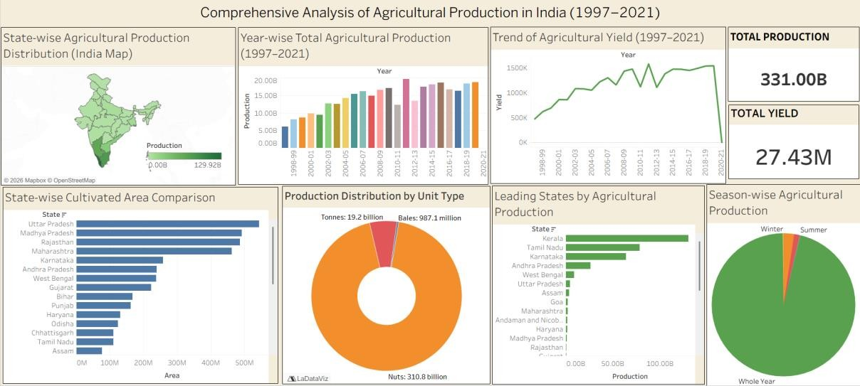
Figure 1: Published dashboard - Comprehensive Analysis of Agricultural Production in India (1997-2021).

